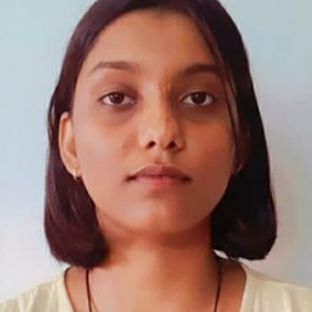
Objective
Motivated and dedicated student seeking an internship opportunity to apply academic knowledge and skills in a dynamic and growth-oriented organization. Eager to contribute to team success while gaining practical experience and further developing professional skills.

Synopsis
Result oriented, effective teamwork, possessing an analytical blend of mind combined with problem solving skills:

- Possessing an analytical blend of mind combined with problem solving skills.
- Ambitious, hardworking and committed to excellence.
- Adept at working in high pressure environments with strict deadlines and multiple deliverables.
- Quick Learner and highly trainable.
- Adaptable, Out of The Box thinker with a goal to establish long lasting relationship with the Organization.

core competencies

- Visionary Leadership
- Detail Oriented
- Team Building

Academic credentials
- BACHELOR OF ENGINEERING – CSE(Batch of 2026): GSSS Institute of Engineering and Technology for Women(VTU Affiliated) CGPA - 7.36
- HIGHER SECONDARY EDUCATION(PCMC): Jindal Vidya Mandir School Vidyanagar, Bellary – Karnataka(CBSE) with 63.4% in the year 2022
- SECONDARY EDUCATION: Jindal Vidya Mandir School Vidyanagar, Bellary – Karnataka(CBSE) with 65.4% in the year 2020

TOOLS WORKed on/languages
- PROGRAMMING LANGUAGES: C&Java(basics), Python(Intermediate).
- WEB DEVELOPMENT: MYSQL, HTML, CSS, JavaScript.
- TOOLS: Jupyter Notebook, Spyder IDE, Ubuntu, IntelliJ IDEA Community Edition 2023, VS code.
- Version Control: Git&GitHub.
- HackerRank: Gold Badge in C, Python and Java, Bronze Badge in SQL.
- Soft Skills: Cyber Security, Cloud Computing.

PROJECT:
- Tic Tac Toe Game: A responsive game for mobile and web, with alternating turns, win and draw detection, and a smooth, user-friendly experience across devices and screen sizes.
- Notes website: create, edit, store, and share notes online, providing a user-friendly platform for organizing thoughts, tasks, and information.
- Portfolio: A portfolio project is a personal project that showcases your work, skills, and achievements. It typically includes sections like an about me, projects, skills, resume, and contact information. Your portfolio can be a website, a PDF document, or a GitHub repository, depending on your field. A well-crafted portfolio helps you stand out to recruiters and potential employers.
- Simple Calculator: A simple calculator project performs basic operations like addition, subtraction, multiplication, and division. It takes user input for numbers and operation choices, handles errors (like division by zero), and displays the result. It's a great beginner project to practice programming concepts like functions and user input.

Certifications
- Training and certification from the World Leading Technology brands-AMAZON WEB SERVICES (AWS) Academy Data Engineering.
- Certified course from Sololearn: Introduction to C programming.
- Certified course from Great learning: Introduction to Cyber security.
- Attended the AWS GENERATIVE AI IDEATHON organized by Aspire For Her in partnership with AWS.
Achievements
- Achieved B Certificate for NATIONAL CADET CORPS (NCC) Army wing with rank LANCE CORPORAL (L/CPL), by NCC Directorate: Karnataka & Goa.
- GSSSIETW Engineering College Elected for Secretary in Music club for the year 2022-2023 and organized and managed various cultural events etc.
Workshops
- Completed 3 days National level Training program entitled “Cybersec Bootcamp and CyberGuard” conducted by Dalvik Apps and Wecan Education on 3rd December 2024. (Certified)
- Attended 3 days Java workshop on 8th January 2024.
Extra Curricular Activities
- NSS
- Swimming
- Boxing
- Actively participated in various games and social activities.

languages:
- English.
- Hindi.
- Kannada.

